Help GSAFE raise $6,000 to Send LGBTQ+ Youth Activists to Camp on Tuesday, July 24, 2018

GSAFE’s 19th annual Leadership Training Institute is coming up soon, and we’re inviting our friends, supporters, and past campers and their families to help us raise $6000 to send the next batch of LGBTQ+ youth activists to camp! Will you help us? Here are the details:
- Who/What – GSAFE is looking for 50 people like YOU to use social media to invite your network to make small donations to help send youth activists to LTI!
- When – Tuesday, July 24th throughout the day (but especially at 10AM, Noon, 5PM, 10PM)
- How – There are a few ways to support this effort:
  - Share “Send an Activist to Camp” posts throughout the day on July 24th. We’ll be adding images and posts on our GSAFE Facebook page all day long, as well as to our “Secret” Facebook group for folks helping us raise money. The link to the “secret” group is: https://bit.ly/2zTNkWP. Please join the group if you aren’t already part of it. Make sure to check in throughout the day to find our latest update for sharing. We will provide you with suggested talking points and a link. Here are two examples (NOTE: We’ll be posting updated messages and images on the 24th – please use those! The following is just an example):

GSAFE’s Leadership Training Institute literally changes the lives of LGBTQ+ youth in Wisconsin. Each year dozens of youth activists develop and hone their leadership and advocacy skills over four days of workshops, community development, and fun. GSAFE is trying to raise $6000 TODAY to send the next generation of activists to their summer leadership camp. Please consider giving $5, $10, $25 or more RIGHT NOW! tinyurl.com/gaycamp2018 #gsafe #lgbtqyouth

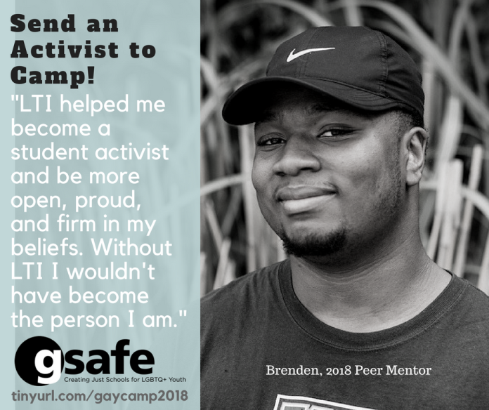

GSAFE is looking to raise $6000 TODAY to help send the next generation of youth activists to their Summer Leadership Institute. Supporters like YOU have already chipped in to send seven activists to camp. Help GSAFE send another youth leader to camp by giving $5, $10, $25 or more RIGHT NOW!
tinyurl.com/gaycamp2018 #gsafe #lgbtqyouth

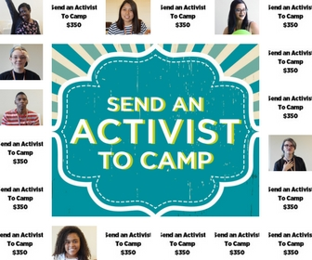

Feel free to add a personal spin to your posts, or share your personal story about how you (or someone you know) benefitted from LTI or other GSAFE programs. Just make sure to include an invitation to give and the link to our donation page.

  - Tag friends and family on posts at key times throughout the day. We’ll create and share with you specific images that challenge people to give “$10 at 10AM”, “$12 at Noon”, “$5 @ 5PM”, and if needed “$10 @ 10PM”. Your job is to post those images at the designated time (or as close as possible) and tag up to 50 friends or family asking them to donate and/or share the post on their own page. 50 is right around the limit of how many people you can tag before Facebook warns you to cool it for a while or they’ll cut off your access for a few hours. We want to plaster FB with these images and create excitement for supporting LGBTQ+ youth leaders.

GSAFE does an amazing job at helping LGBTQ+ youth build and hone their leadership skills. Please give $5 or more RIGHT NOW to help send the next generation of activists to GSAFE’s summer leadership camp!” tinyurl.com/gaycamp2018 #gsafe #lgbtqyouth
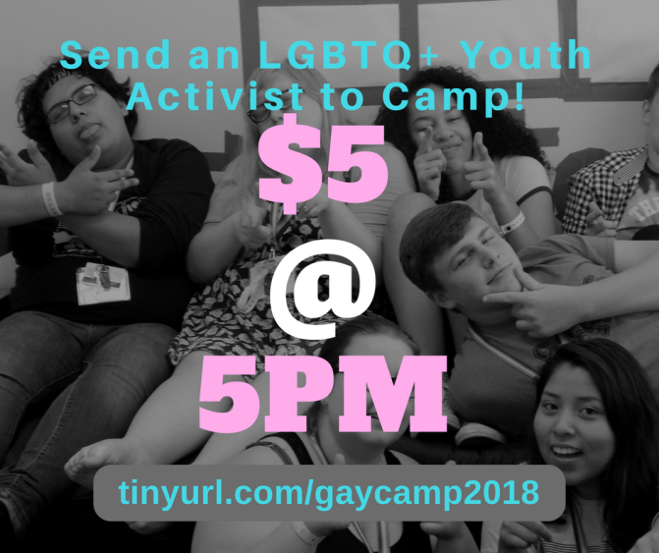
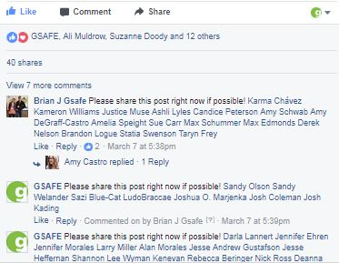
Note the tagged names in the comments section!

  - Go LIVE on Facebook. We’re looking for 15-20 people who will go live on Facebook at specific times throughout the day on July 24th. Ideally your video will last between 5-10 minutes to give people enough time to notice you are broadcasting and tune in. Here are some examples of videos of GSAFE supporters showing us some love for another fundraising event:
https://www.facebook.com/kirk.nichols.5/videos/10101533790124803/
https://www.facebook.com/ameline.degraff/videos/1879233872314487/
https://www.facebook.com/maria.k.peeples/videos/10155085789613343/
You wouldn’t have to talk about GSAFE or LTI the entire time – people usually just want to see YOU when you go LIVE – but we invite you to mention us a couple of times, talk about the impact of LTI (if applicable), and tell people how to donate. Make sure to make the video public (if willing) and tag #gsafe so we can reshare your video on our FB page.

Donate at: tinyurl.com/gaycamp2018
Got questions? (608) 661-4141 or brianj@gsafewi.org. Thanks for helping queer youth thrive!

